HYDRAULIC JACK
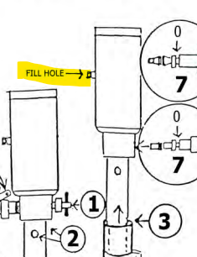
ADDING OIL

RED TRANSMITTION FLUID – ATF

JACKS ARE ON CAMPER:

Retract jacks all the way IN
Remove fill hole Hex Head Bolt
Use Syringe to fill up to the bottom of the fill hole

JACKS ARE OFF CAMPER:
Lay jacks on side.
Pour ATF fluid into fill hole.
Do not replace hex bolt.
Stand up jack to let excess oil to drain out.
Replace Hex Bolt.

